

v1.0.0
Documentation

© Light Lab PRO. 2026

Initial Setup
Light Lab PRO is an intuitive tool engineered for Unity, providing a streamlined interface to manage and manipulate lighting settings efficiently.

1. Purchasing the tool
- Go to the Unity Asset Store and search for Light Lab PRO.
- Add to cart.
- Proceed to checkout.
- Confirm payment.

2. Installation & Setup
- Go to Package Manager in your Unity Editor and follow the on-screen instructions to install Light Lab PRO in your Unity project.
- Locate the folder under Assets/LightLabPRO
- Select which tool to use under Window/Light Lab PRO/
- After you have selected the tool, it will automatically load all available lights in your current scene.
- The tool will also generate a Scriptable Object to manage groups between scenes.

Lighting FX & Settings Window

3. User Interface Overview
- Light Groups: A section where the user can group lights by selecting them from the light list. This section is collapsible and each group is also collapsible. Users can create a new group by entering a name on New Group Name and pressing Create Group. Options include Rename Group, Add Selected Lights (select lights on the light list), and Delete Group. In-group options include edit, which focuses on the light and enables it for editing and delete, which deletes/removes a single light from the group.

  - IMPORTANT: Press the Save Light Group Data button to save your groups. They will not pass over between scenes. Each scene will have its own Light Group Data scriptable object (created automatically by the tool and saved in the Light Group Data folder in Assets/Light Group Data.

- Light List: A comprehensive list displaying all lights in the scene. Options include selecting/deselecting all lights, and individual selection via a checkbox.

- Light Details: Each light entry displays the light name, mode, type, a focus button to center the view on the light, and an enable/disable toggle.
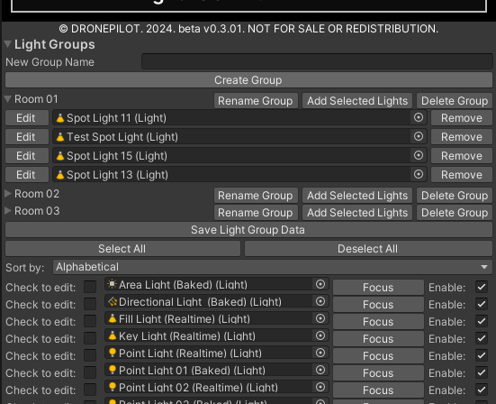

4. Light Operations
- Sorting Lights: Utilize the dropdown option at the top to sort lights based on your preferences: Alphabetical, Type, Both.

- Selecting Individual Lights: Click on the light name within the tool to select a specific light.

- Editing lights: Click/Toggle on the checkbox on the left, next to “Check to edit’, to enable the light editing options.
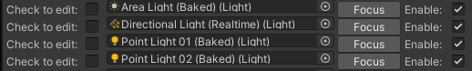
- Enabling/Disabling Lights: Use the toggle button beside each light to enable or disable it.

5. Light Settings
- Applying Presets: Select the desired preset from the dropdown menu and click the "Apply Preset" button.

- Removing Presets: To remove a preset, simply click the "Remove Preset" button.

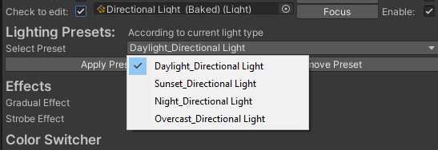

6. Effects
- Gradual Effect: Adjust the minimum and maximum intensity and range values. The "Gradual Speed" slider controls the speed of change between these values.
  - Behavior: Determines the behavior of intensity.
    - Forward: Increases intensity from minimum to maximum continuously.
    - Reverse: Decreases intensity from maximum to minimum continuously.
    - PingPong: Intensity goes from minimum to maximum, then back down to minimum continuously.
    - Random: Randomly changes intensity within the set range.

(NOTE: BEHAVIOR FOR RANGE WILL BE ADDED IN A FUTURE UPDATE.)
- Strobe Effect: Similar to the Gradual effect but changes are instant. The "Strobe Speed" slider controls the speed of the strobe effect.
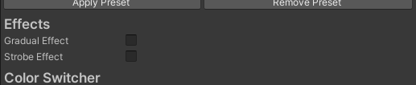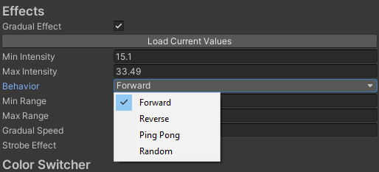
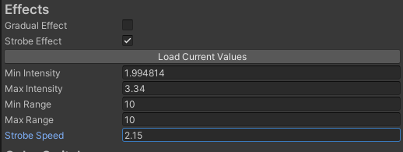

- Gradual & Strobe effect: An effect that combines both the Strobe and Gradual effects for your lights.
  - Strobe Interval: Controls how many strobes take place inside the set speed
  - Strobe Duration: Controls the duration of the strobe inside the gradual effect
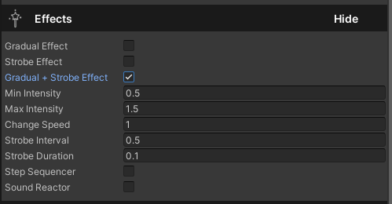
- Step Sequencer: Assign intensity and range to lights in up to 12 editable steps. You can also select the step duration and how many steps the effect has.
  - Enabled: Enables or disables the step. Next enabled step is applied during runtime.
  - Intensity: Light intensity during this step
  - Range: Light range during this step

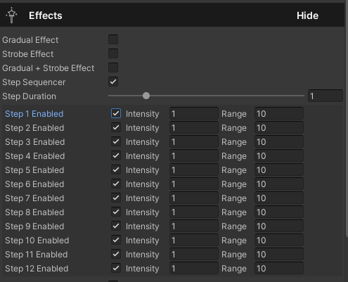

- Sound Reactor: Lights react to the assigned sound clip volume. You can tweak the base intensity which will determine how much the sound affects the light, color change speed, change threshold, and colors of the light depending on the intensity.
  - Intensity Multiplier: Determines how much will the sound clip volume affect the light intensity
  - Base intensity: Sets a floor threshold on how much the intensity is affected
  - Color Change Speed: Determines how fast the color changes when intensity is over threshold
  - Base Color: Sets base color before passing threshold
  - Threshold: Sets the threshold for color change based on intensity
  - Reaction Color: Sets color after threshold is passed
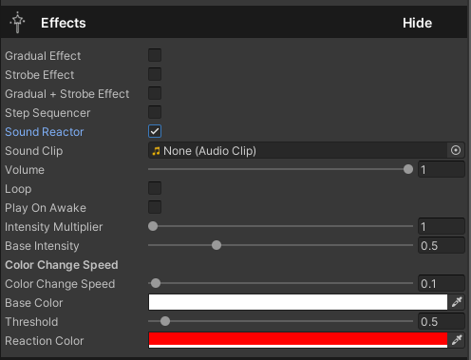

7. Color Switcher
- Add or remove colors to the list. Set the pattern to forward, reverse, or random. Choose between instant or gradual change types, and adjust the switch speed.
  - Load Current Color: Loads the current set color on Basic Settings
  - Colors: Array of added colors on the effect which will take place
  - Add Color: Add a new color to the effect
  - Remove Last Color: Removes the last color on the array
  - Pattern: This affects the behavior of the light change. Forward (list from top to bottom), Reverse (list from bottom to top), Random (colors are applied randomly)
  - Change Type: Determines how the color change takes place, either Instant or Gradual
  - Switch Speed: Sets the speed of color change
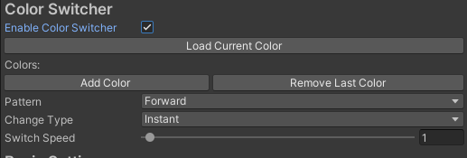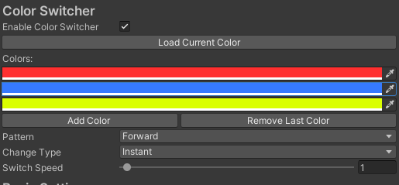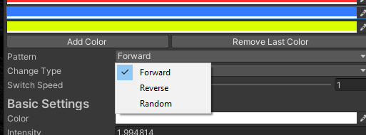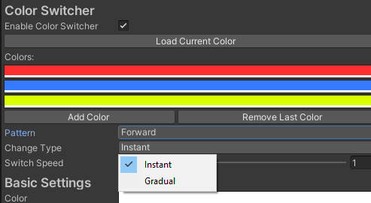

8. Sound Effects
- Press “Add Sound Effect” to add a sound component to the light gameobject.
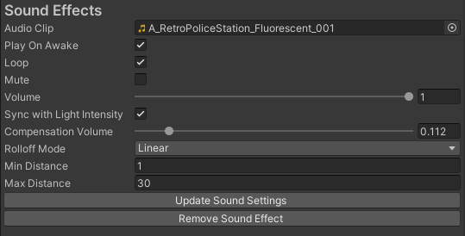
- It has many options from the Audio Source component, such as:
  - Audio Clip (load audio clip you want played)
  - Play on Awake: sound starts when gameobject is enabled
  - Loop: sound repeats when clip reaches the end
  - Mute: stops audio playback
  - Volume: select intensity of audio clip
  - Rolloff Mode: Select how sound behaves and decays in relation to the Audio Listener
  - Min and Max distance: limit how close and how far from the source the audio is played. This works in correlation to the Rolloff Mode which makes the sound intensity vary according to Audio Listener position

- Light Lab PRO settings:
  - Sync with Light Intensity: Audio volume/intensity is set according to light intensity to simulate a more realistic sound effect.
  - Compensation Volume: if light intensity reaches a certain minimum value and/or 0, the compensation volume adds additional volume so audio db value isn’t 0.

9. Basic Settings
- Modify the color, intensity, light type, range, and shadow type of the selected light.
  - Color: change the light’s color using the color selector
  - Intensity: Set light intensity by entering value manually or sliding by hovering over the intensity label
  - Light Type: Choose between directional, spot, point, area, rectangle, disc.
  - Range: Set light range depending on light type
  - Shadow Type: Choose between soft shadows, hard shadows, and no shadows
  - Light Mode: Choose between Realtime, Mixed, Baked.

Material Changer
Feature that adds dynamic update of the material Albedo or Emission depending on the light's current color.
- Target GameObject: Choose which gameobject to apply the effect.
- Instantiate Materials: Make a single material to affect or affect a material which other gameobjects might have.
- Albedo Change: Light will affect the albedo.
- Emission Change: Light will affect emission.
- Emission Multiplier: Amount of emission to be affected.
Apply Material Changer
- Click the "Apply Material Changer" button to apply dynamic change of the material depending on the light color.
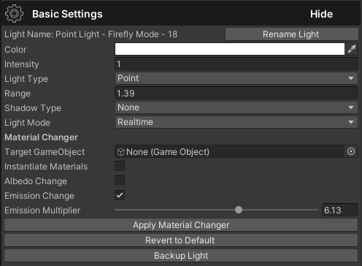

10. Reverting to Default
- Click the "Revert to Default" button to reset the selected light to its default settings as if it was freshly created.


Light Animator Window

11. User Interface Overview
- Light List: A comprehensive list displaying all lights in the scene. Options include selecting/deselecting all lights, and individual selection via a checkbox.

- Light Details: Each light entry displays the light name, type, and a focus button to center the view on the light.

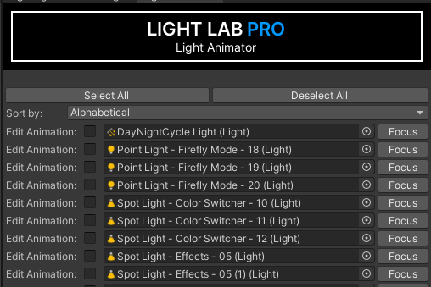

12. Light Operations (Light Animator)
- Sorting Lights: Utilize the dropdown option at the top to sort lights based on your preferences: Alphabetical, Type, Both.
- Selecting Individual Lights: Click on the light name within the tool to select a specific light.
- Editing lights: Click/Toggle on the checkbox on the left, next to “Edit Animation’, to enable the light animation editing options.

13. Animation Settings (Light Animator)
- Rotator Mode: Choose between Forward, Ping Pong, and Random.
  - Forward: The light will start rotating on the axis where you applied values. IMPORTANT: apply negative values to move in reverse.
  - Ping Pong: Light rotates back and forth between the set angles and rotation speed.
  - Random: Light rotates randomly on the axis where you applied values.
  - Apply Rotation on Axis:
  - Apply Rotation Animation: Applies the script component with the set behavior on the light/gameobject.
  - Reset Rotation Animation: Resets the values and behavior of the animation script.
  - Remove Rotation Animation: Removes the animation script from the light/gameobject.
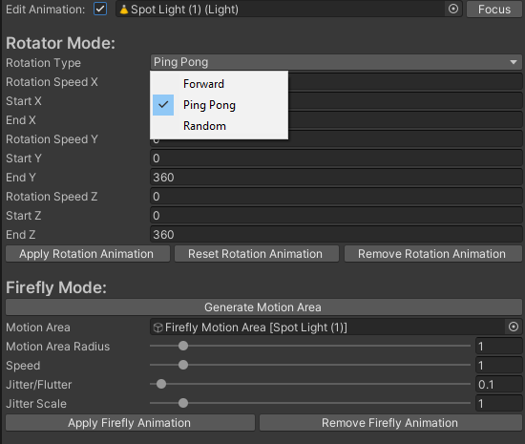

- Firefly Mode (interface): Apply an organic, fluttering, jittery, firefly-like behavior to lights.
  - Generate Motion Area: This will generate an area where your light will flutter in. The created gameobject will be automatically loaded into the tool. You can use the same Firefly Motion Area for multiple lights. The motion area is displayed with a green sphere gizmo.
  - Motion Area Radius: Increase or decrease the radius of the motion area
  - Speed: Set the movement speed of the light inside the motion area.
  - Jitter/Flutter: Applies jitter/flutter in relation to the jitter scale. Higher values = more jittery and tighter movement. Lower values = less erratic and covers more space.
  - Jitter Scale: increases or decreases area of jitter.
  - Apply Firefly Animation: Applies the Firefly script and behavior to the light/gameobject.
  - Remove Firefly Animation: Removeses the Firefly script and behavior from the light/gameobject.

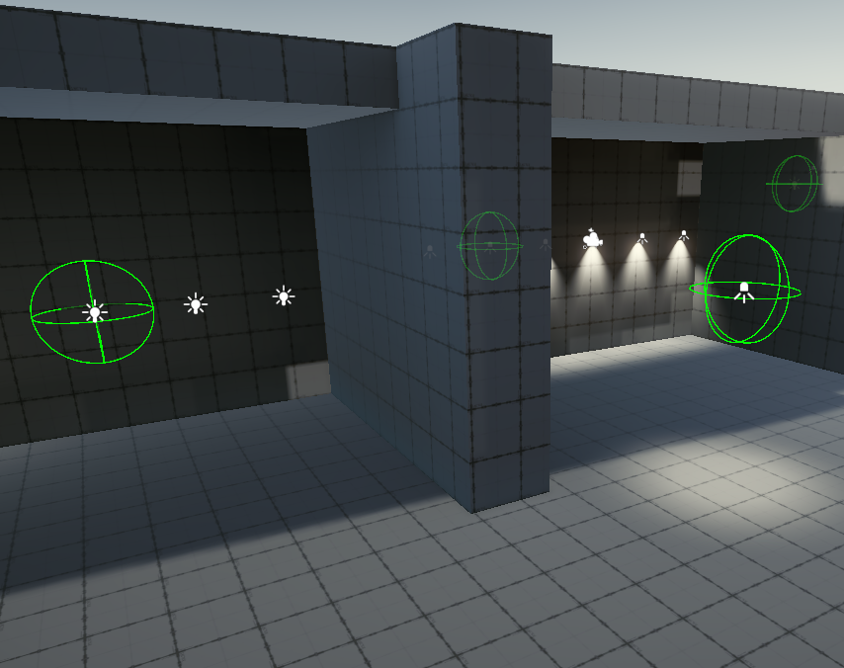

Day & Night Cycle

Apply by creating an empty gameobject, then add the DayNightCycle.cs script to the empty gameobject.

14. Setup Day & Night Cycle
- Light GameObject: Load the Directional Light you will be using with the Day & Night Cycle.
- DayNightCycle Config: Load the DayNightCycle Config scriptable object that will affect your Directional Light.
- Create Light: Creates a new Directional Light.
- Create Skybox: Creates a new Skybox that uses a High Quality sun.

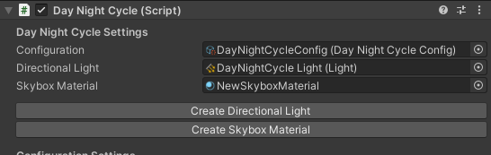

15. Time Settings
- Hour: Sets starting hour
- Minutes: Sets starting minute
- Seconds: Sets starting second
- Cycle Speed: Sets the speed of the Day & Night cycle (adjust as needed).

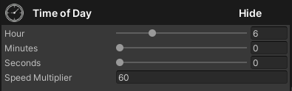

Sun Rotation Settings:
Applies rotation on the Y axis to directional light
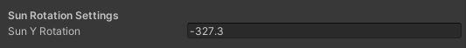

16. Intensity Configuration
- Sunrise Intensity: Sets light intensity during sunrise
- Day Intensity: Sets light intensity during day
- Sunset Intensity: Sets light intensity during sunset
- Night Intensity: Sets light intensity during night

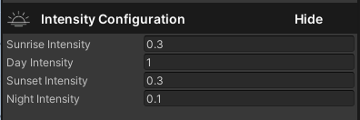

17. Color Configuration
- Sunrise Color: Sets color during sunrise
- Day Color: Sets color during day
- Sunset Color: Sets color during sunset
- Night Color: Sets color during night
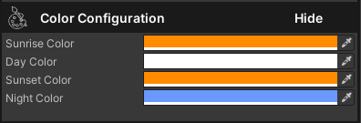

19. Sun size settings (will get properly named later)
- Sunrise sun size: Sets sun size during sunrise
- Day sun size: Sets sun size during day
- Sunset sun size: Sets sun size during sunset
- Night sun size: Sets sun size during night
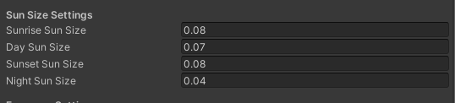

20. Exposure settings
- Set skybox exposure for each day period
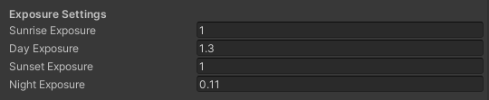

21. Additional Skybox Settings
- Set skybox settings for each day period
- Choose sun disk type

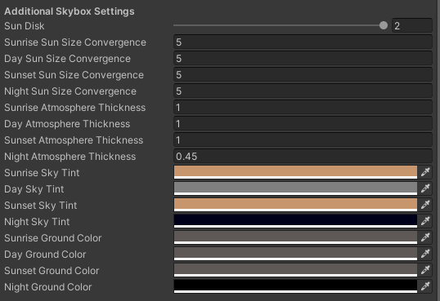

Troubleshooting
- Check Console for Errors: Inspect the Unity Console for any errors or warnings that may provide insight into the issue.
- Update Unity: Ensure you are using a version of Unity that is compatible with Light Lab PRO.
- Re-import Tool: Sometimes re-importing the tool can solve unexpected issues.
- Check Documentation: Refer back to this documentation and ensure all steps were followed correctly.
- Contact Support: If issues persist, contact support at info@lightlabpro.com for further assistance.

22. Known Bugs
- Values reset on Basic Settings
- Light range resets on Gradual effect
- Light range resets on Strobe effect
- Light groups only lets lights to be added once
- Speed/Time values in Ping-Pong behavior on Rotator Mode are too sensitive
- Day & Night Cycle tool assigned assets need to be loaded after each playtest, or scene load

Contact Information
For further assistance or inquiries regarding Light Lab PRO, feel free to reach out to us via email at info@lightlabpro.com. Our support team is always ready to assist you with any concerns, bug reports or feedback you may have regarding the tool.

